# 4.4 Activity and Swimlane Diagram

Activity diagram shows the technical view of the system for every use case from which I can understand how the system actually works and how the actors interact with the system. Here is the activity and swim lane diagrams for use the use cases stated before.

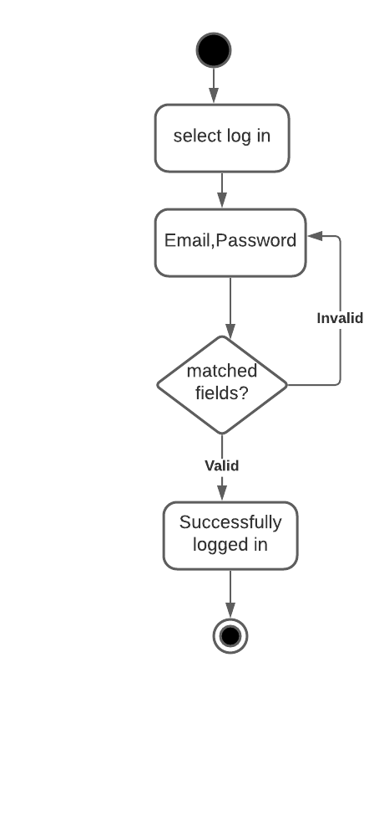

Figure 15: Admin login Activity

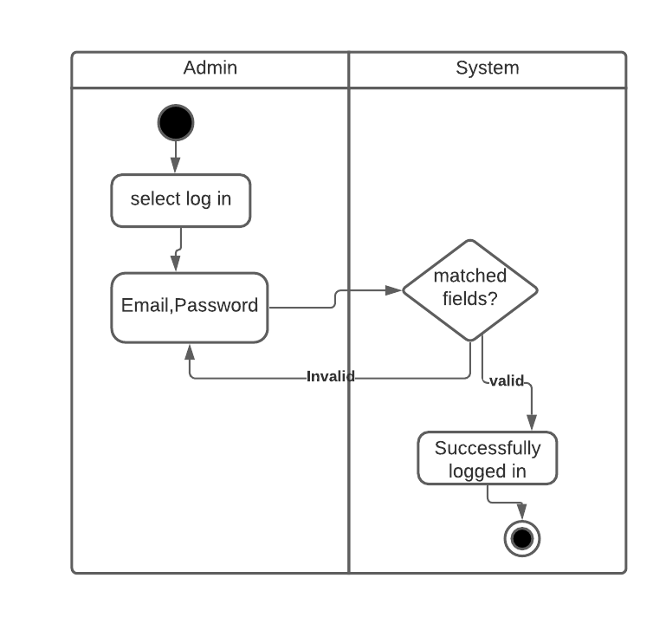

Figure 16: Admin signin swimlane

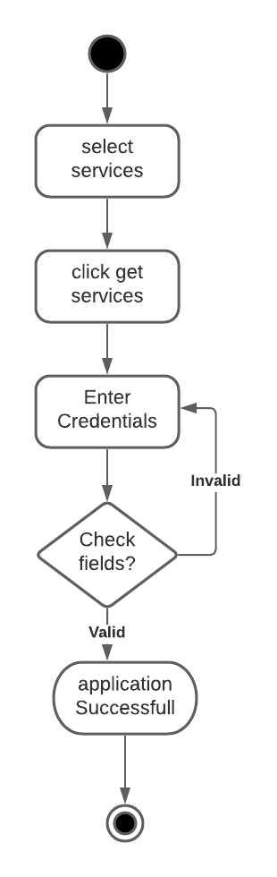

Figure 17: Application or sign-up activity

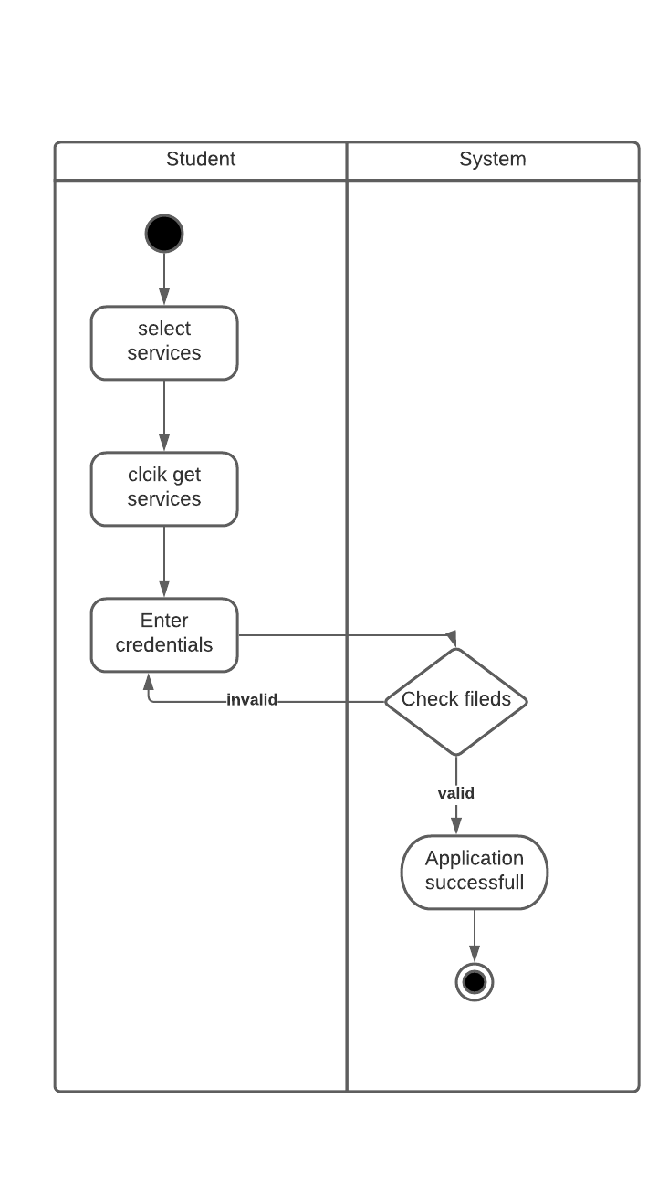

Figure 18: Application or sign-up swimlane

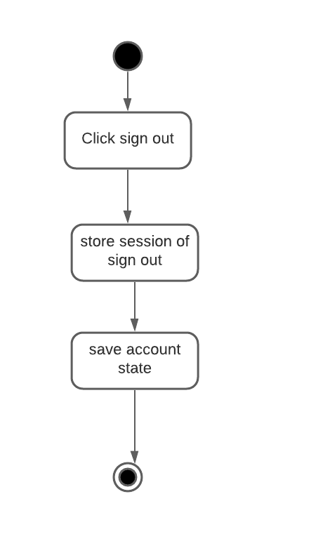

Figure 19: Sign out activity

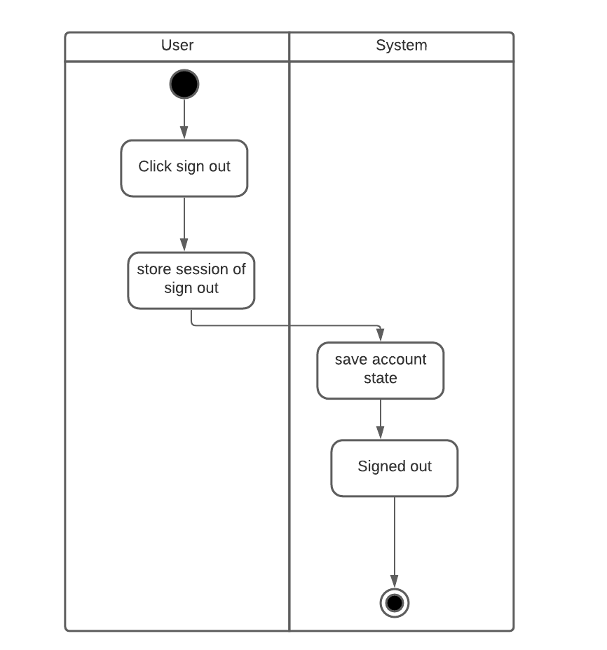

Figure 20: Sign out swimlane

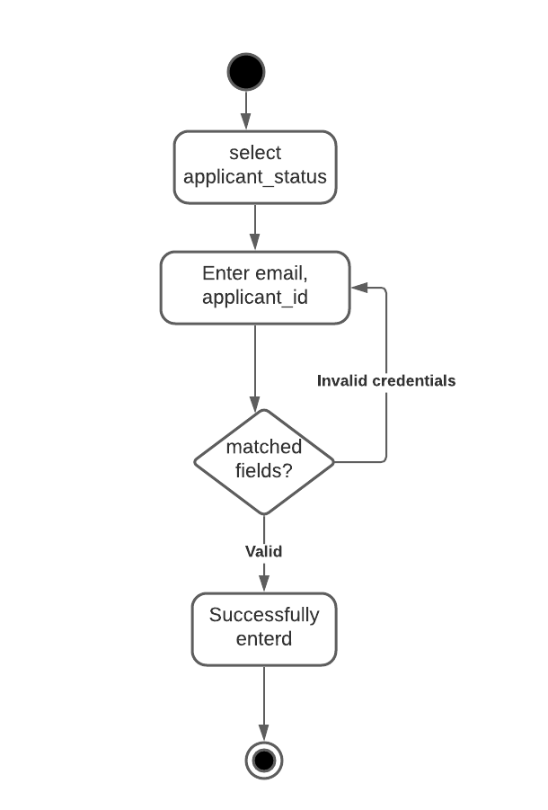

Figure 21: Application status Activity

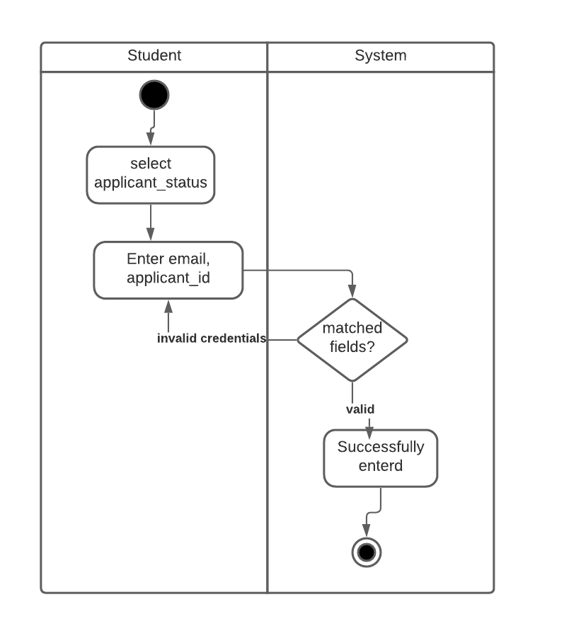

Figure 22: Application status Swimlane

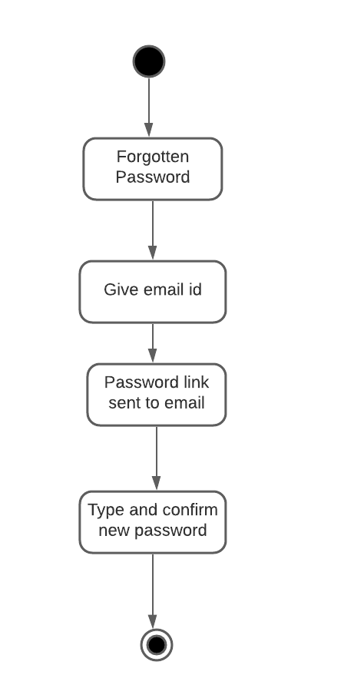

Figure 23: Recovery password Activity

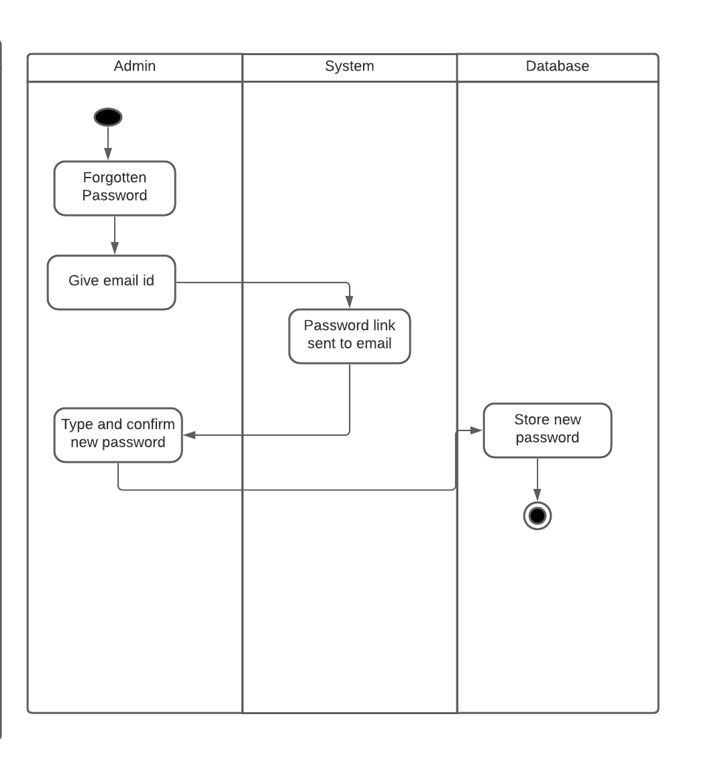

Figure 24: Recovery Password Swimlane

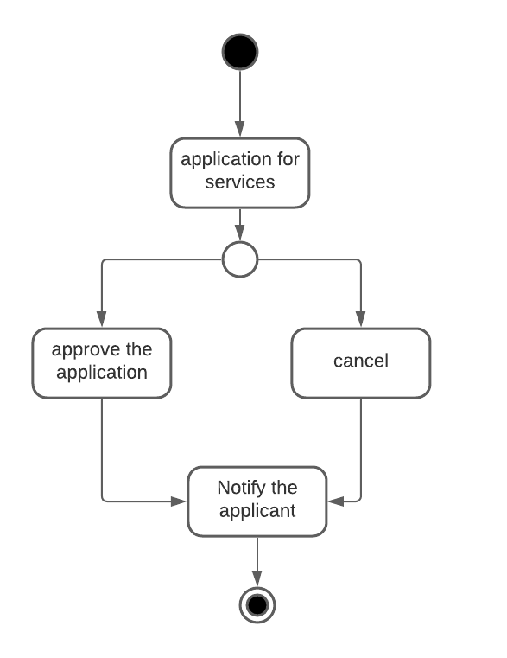

Figure 25: Approve-Cancel Activity

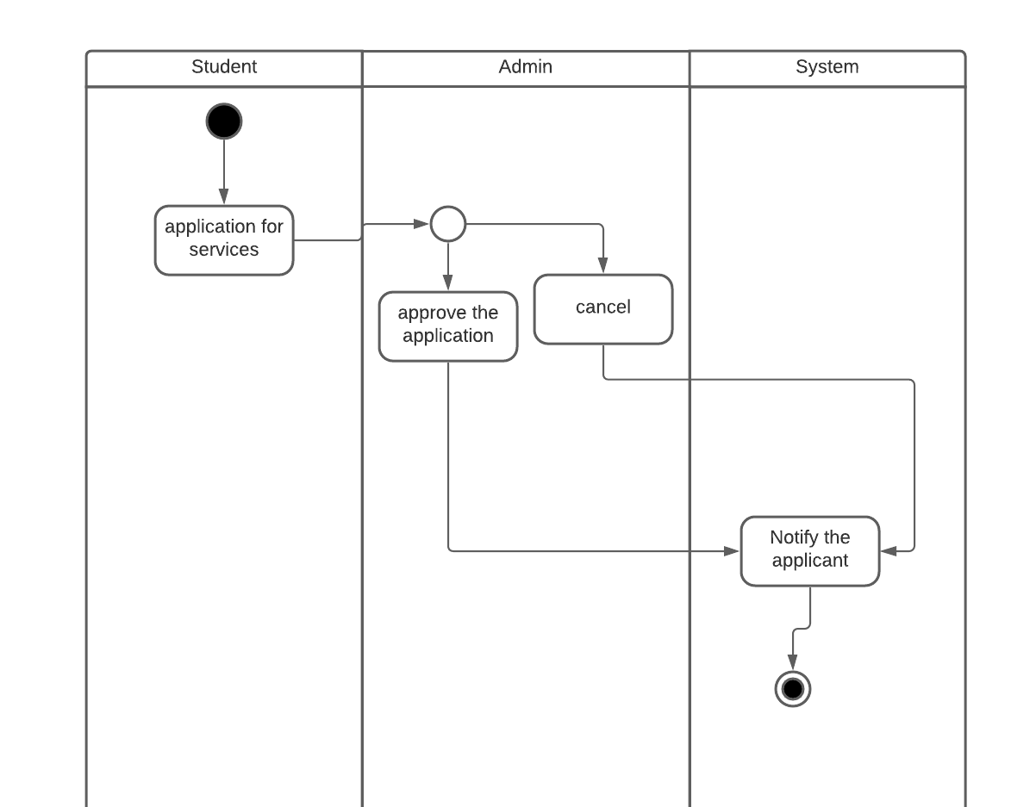

Figure 26: Approve Cancel Swimlane

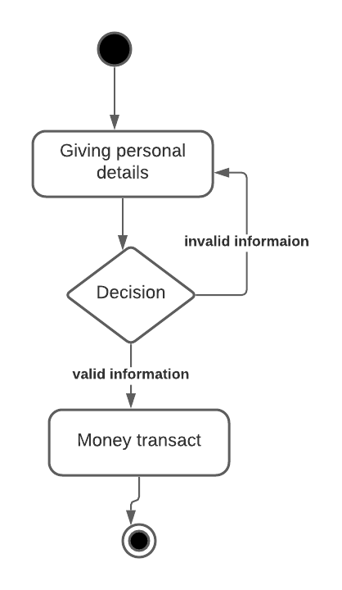

Figure 27: Application Activity

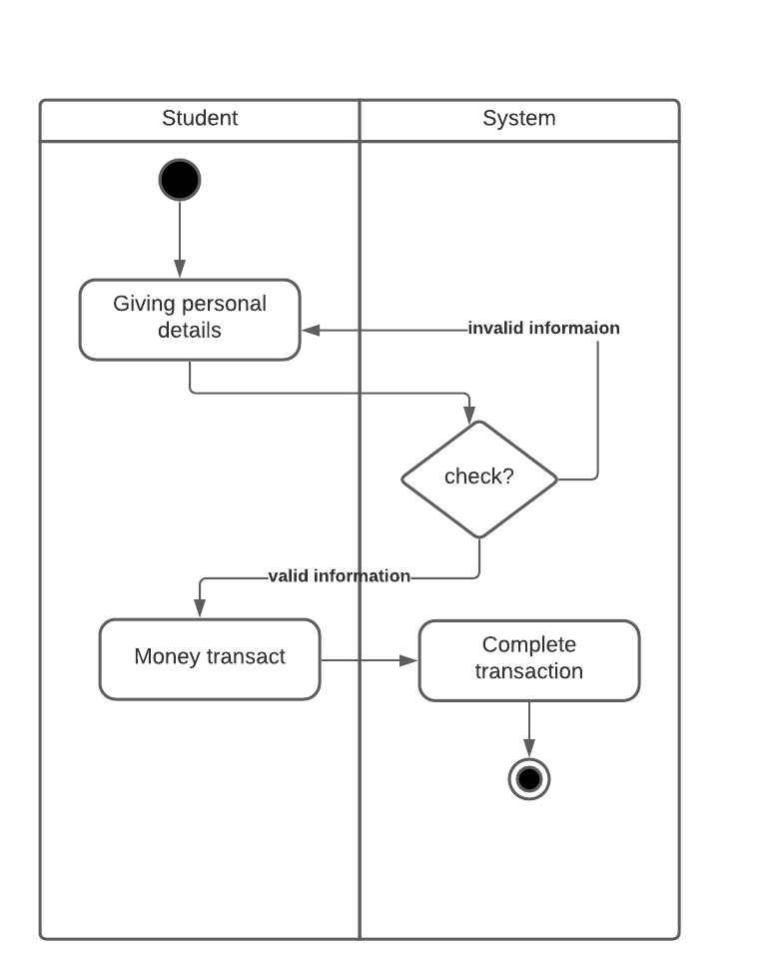

Figure 28: Application Swimlane

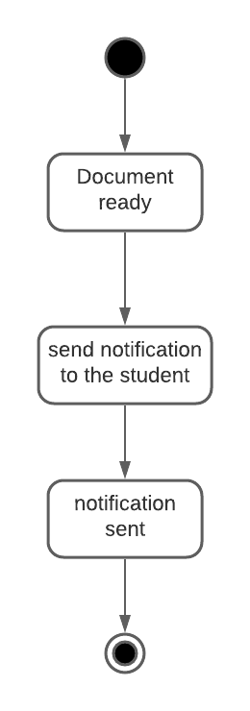 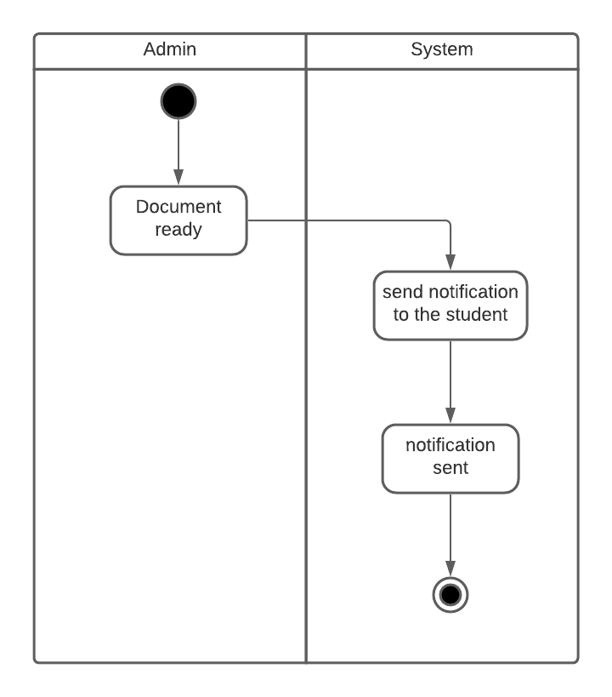

Figure 29: Notification Activity Figure 30: Notification Swimlane

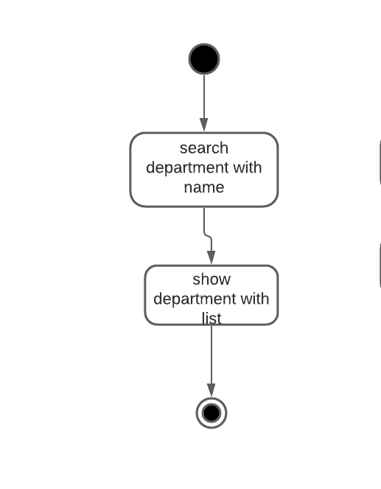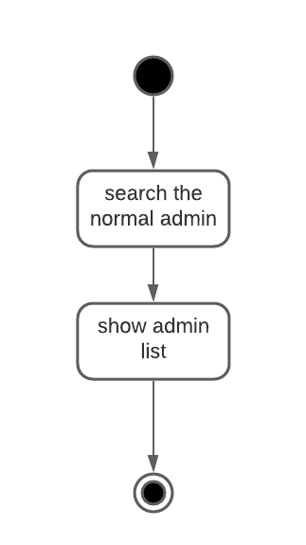

Figure 31: Department Search Activity Figure 32: Search Admin Activity

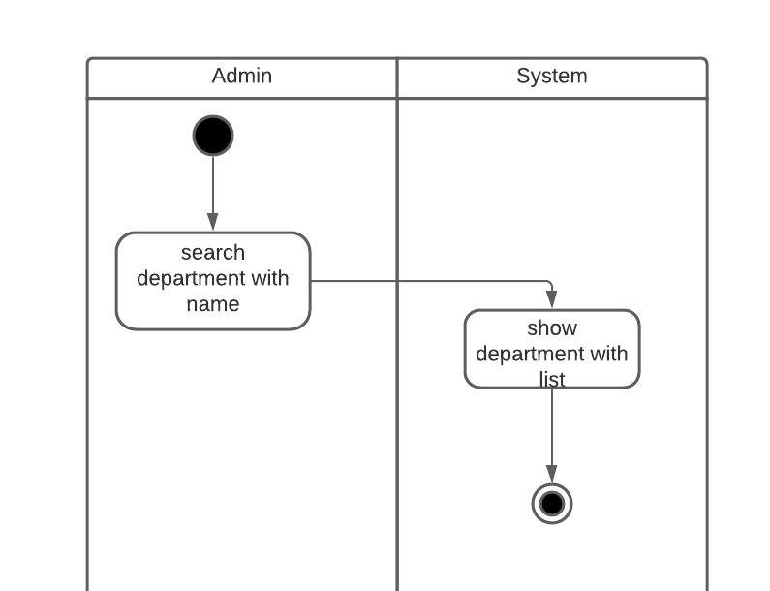

Figure 33: Department Search Swimlane

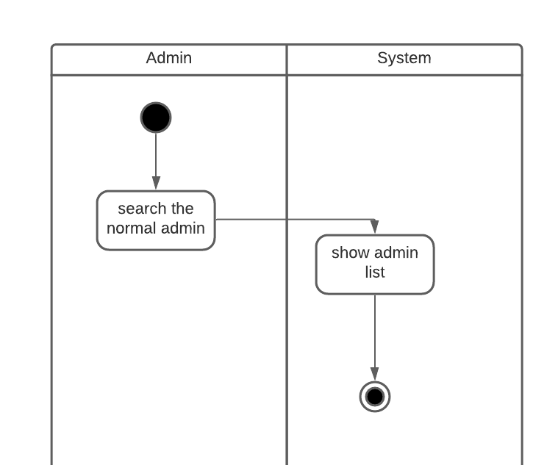

Figure 34: Admin Search Swimlane

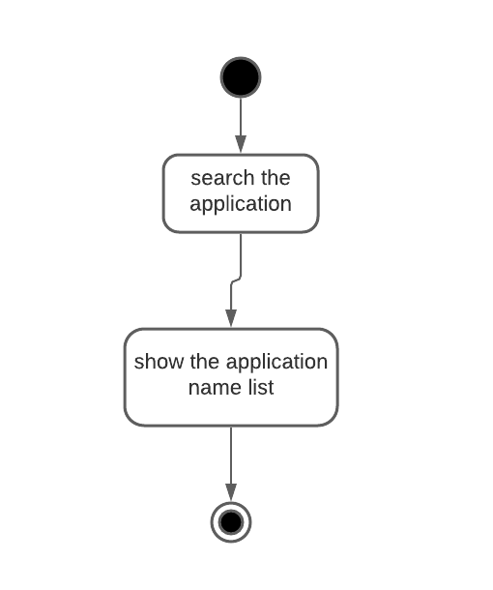

Figure 35: Applicant Search Activity

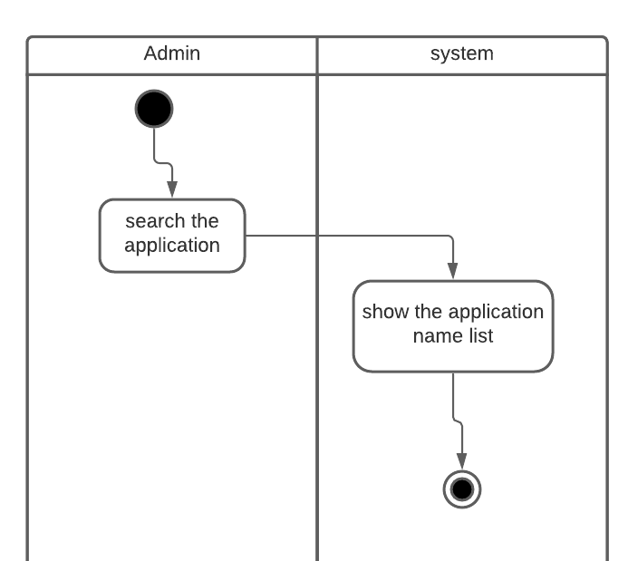

Figure 36: Applicant Search Swimlane

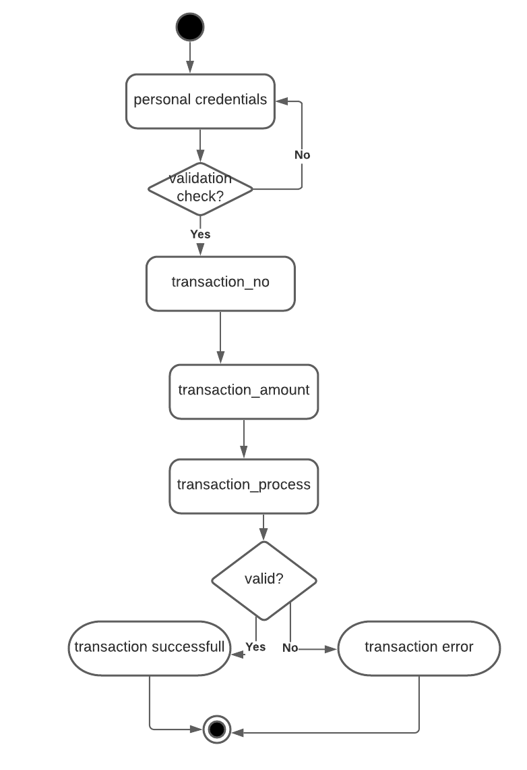

Figure 37: Transaction Activity

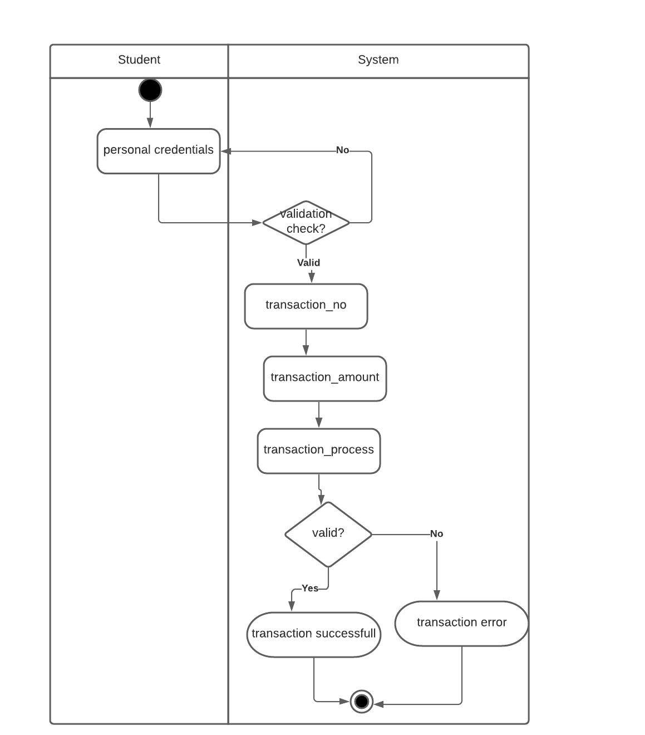

Figure 38: Transaction Swimlane

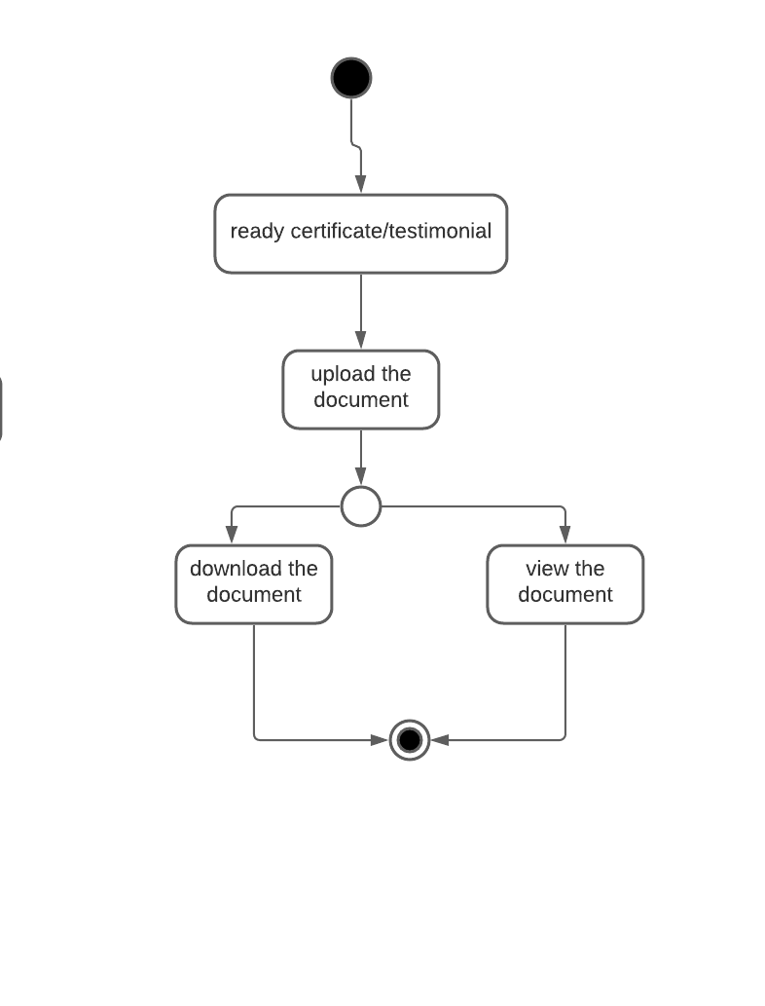

Figure 39: Upload download Activity

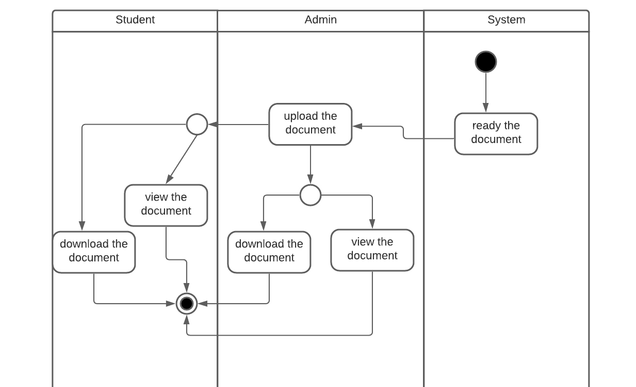

Figure 40: Upload download Swimlane